CAPITAL PROGRAMS
PROJECT PLANNING AND DEVELOPMENT
AUDIT REPORT #21-2102

Audit & Advisory Services
June 2021

CAPITAL PROGRAMS
PROJECT PLANNING AND DEVELOPMENT
AUDIT REPORT #21-2102

Background

In accordance with the Campus fiscal year 2020-21 audit plan, Audit & Advisory Services (A&AS) performed a review of internal controls and associated procedures related to the planning and development activities of major construction projects within the Capital Programs department.

The Capital Planning and Finance unit leads and coordinates the project study, planning, and project approval phases of major capital construction projects for UCLA. Projects having total costs of $1,000,000 and above are considered major capital construction. The unit works with campus clients, typically within the context of the Long Range Development Plan, to assist in verifying the need for a given capital construction project. Once project need is established, Capital Planning and Finance personnel help to define the scope of the project, and develop the pertinent documentation (including project budgets, time frames, and architectural plans) to present to campus administration for review and approval. As noted in the Annual Report on Major Capital Projects Implementation for fiscal year 2018-19 (the most recent published information available), the University of California (UC) system had 349 major capital projects totaling approximately $6.8 billion. Of these, UCLA had nine active projects totaling $1.1 billion.

UCLA Capital Programs is delegated responsibilities in four broad categories: Concept Planning – developing a basic understanding of the programmatic and functional requirements of the program or facility; Detailed Planning – including space programming to establish the functional requirements, financial feasibility, cost analysis, environmental analysis, land use, funding plan; Design Phase – selection of professional architectural services for schematic designs, identifying budget and code requirements, areas of regulatory and environmental compliance; and Construction Phase – including the contract and bid award process, monitoring and inspection activities to ensure quality and adherence to approved design, building occupancy and project closeout. The UC Facilities Manual (Vol. II-III) provides general guidelines for the processes.

The Associate Vice Chancellor for Capital Planning and Finance oversees the administration of the following key functions for campus capital construction projects: program planning, project development, financial services, contract administration, and records management. Inherent within these broad functions is the responsibility for review and approval of initial project studies, definition of project scope, coordinating project financing through the Financial Services unit, and regularly interacting with project clients.

Purpose and Scope

The primary purpose of the review was to ensure that Capital Programs internal controls and procedures relating to capital project planning activities are conducive to accomplishing its business objectives. Where applicable, compliance with Campus and University requirements was also evaluated.

The scope of the audit focused on the following areas:

- Concept Planning
- Detailed Planning Process
- Project Funding and Approval
- Project Transition Process

The review was performed in accordance with the International Standards for the Professional Practice of Internal Auditing and included interviews, tests of records, and other auditing procedures considered necessary to achieve the audit purpose.

Summary Opinion

Based on the results of the work performed within the scope of the audit, Capital Programs’ internal controls and procedures relating to project planning and development activities were found to be adequate and effective in helping to achieve its business objectives. There were no significant control weaknesses identified during the audit.

The audit results are detailed in the following sections of the report.

Audit Results and Recommendations

Concept Planning

Concept Planning is the early development of projects, and consists of many elements that determine whether proposed projects are realized or not. After academic and enrollment plans have been discussed in meetings with campus leadership to evaluate the capital needs of the University and justify the projects, a Project Initiation Form is created. The form serves as a starting point to document the basic functional needs of a project and a basis to seek funding. Programming is further developed in the pre-design phase, along with other activities including construction cost and site analysis.

An analysis of the effectiveness of existing space is conducted in a Business Case Analysis study for projects with budgets over $10 million.

Project funding estimates are identified in the early stages of planning and sources must be clearly described. The project's total estimated cost is first documented on the Project Initiation Form and then broken down into phases and expense categories in the Capital Improvement Budget, which is tracked throughout the development of the project. A statement of the proposed funding is located in the Capital Project Summary (projects less than $10 million) or Project Planning Guide (projects greater than $10 million). When necessary, major changes in the scope of a project would be documented in a Project Augmentation Form. Subsequently, the Capital Project Summary or Project Planning Guide would be amended.

The project schedule illustrates the anticipated time frame when the primary project activities will occur. To ensure that the project planning phase progresses forward and construction for the project is not delayed, Capital Programs personnel separately develop a schedule for projects in the concept planning phase that is later transferred to the Master Project Schedule when the design phase is reached. In addition, a list of active projects with any schedule delays and the associated reasons is maintained and distributed to campus administration every few months.

Interviews were conducted with key Capital Programs personnel regarding the department’s practices in capital construction concept planning. From the population of ongoing campus capital projects, A&AS used the current Capital Programs Master Project Schedule (dated July 2020) to select a judgmental sample of recent projects that have completed the planning phase to ensure the following:

- The Capital Planning and Finance unit has followed established procedures to develop the project's basic programmatic and functional requirements for the sampled projects;
- Project definition and scope are clearly defined with preferred recommendations included;
- Construction site and auxiliary jobsite are identified;
- Funding estimates and sources are identified and clearly described; and
- Timelines and/or schedules have been established to ensure that the project planning phase progresses forward and construction for the project is not delayed.

Five major capital projects were selected for audit testing from the “Campus-CP Active Projects” section of the schedule. This section includes projects for which all of the planning documents should have already been completed. Post-Construction projects were not selected because additional effort might have been necessary for the client to obtain and compile planning documents for review that were prepared several months or years prior. The following five capital projects were selected for all testing performed within the audit:

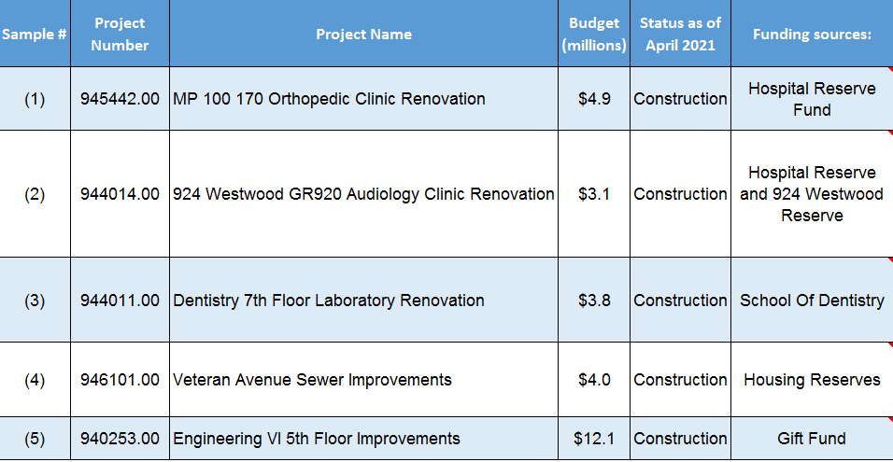

For each of the projects listed in the table above, A&AS obtained relevant documents from the department’s SharePoint system to facilitate our review and evaluation. The types of project documents reviewed included: Project Initiation Form, Project Augmentation Form, Approved Project Documents, Capital Project Summary (and any amendments), Construction Documents, Project Planning Guide, Business Case Analysis, and Bidding documents. The volume and types of documents associated with each project were contingent on the nature, complexity, and total cost of the particular project.

Our review of the five projects and their associated processes indicated that Capital Programs staff complied with established procedures during the Concept Planning phase of capital improvement projects.

There were no significant control weaknesses noted in this area.

Detailed Planning Process

For the Detailed Planning phase of the project, a primary objective of the Capital Planning and Finance unit is to assist clients with defining program objectives and scoping the capital project to address those objectives. The project scope is then formally documented in the project’s Capital Project Summary or Project Planning Guide and Capital Improvement Budget for campus administration, UC Office of the President, and the UC Regents’ review and approval. The nature of the capital planning process is one in which project budgets and schedules accurately reflect the scope and strategic choices made to address the client’s objectives. Once the construction phase begins, except for approved change orders, the scope of work, budget and schedules should remain consistent with existing project approval documentation.

Due to the different levels of complexity and the unique nature of each project, the timing and type of work performed in the project design phases may vary, but they generally fall into four broad areas: Pre-design Phase, Schematic Design, Design Development, and Construction Documents. Projects do not always follow a standard linear process.

Based on the projects selected for review, A&AS performed audit testing to verify the following:

- A Business Case Analysis has been completed that supports either proceeding with or discontinuing the project;
- Environmental impact studies have been completed and documented (if applicable) in the detailed planning document package, based on the UC Facilities Manual and pertinent State construction codes;
- Detailed architectural designs have been completed and documented; and
- Capital Project Summary, Project Planning Guide, and the Capital Improvement Budget have been completed and approved by Capital Programs.

A&AS verified that the essential project documents noted above provided enough support needed to proceed with the five projects reviewed. It was also confirmed that Capital Programs management had approved the required planning documents, including the Capital Improvement Budget. These key documents serve as the source and justification for a capital construction project.

An Environmental Impact Classification form is completed to document that the proposed project has been reviewed and determined that it is: (1) exempt from the California Environmental Quality Act, (2) categorically exempt, (3) not exempt and an Initial Study should be prepared, or (4) known that the project will have a significant effect on the environment and will be substantially analyzed in an Environmental Impact Report. Three of the sample projects reviewed were categorically exempt, i.e., there was no significant effect on the environment. An Initial Study was prepared for one sample project, and an Environmental Impact Report was prepared for the remaining project.

The Schematic Design, Design Development, and Construction Documents are three architectural phases that are commonly used for most projects. Schematic Design is the first phase when the concepts of the design are illustrated and described in three dimensions. This stage is also the research phase of the project when certain requirements, including environmental documents, must be completed. The Schematic Design phase is followed by the Design Development phase, when the structural, electrical, mechanical and other details are further refined. Lastly, the Construction Documents phase establishes drawings and specifications with greater detail. Construction Documents serve as the basis for obtaining bids from contractors, the goal being that a higher level of accuracy should result in fewer change orders in the construction phase.

Our review disclosed that all five projects tested had appropriately developed the Schematic Design, Design Development documents, and Construction Documents.

Based on test work performed, Capital Programs’ practices and protocols facilitate compliance with the applicable guidelines established in the UC Facilities Manual to complete the detailed planning activities of capital improvement projects.

There were no significant control weaknesses noted in this area.

Project Funding and Approval

The project funding and approval processes occur within the Detailed Planning phase of a capital project and vary depending on several factors, such as the size of the project budget, whether the project is State funded, its relationship with long-range development plans, and other special circumstances. All five projects reviewed underwent a budget and design review, which were required in order for the projects to proceed through the development process, and amendments were properly approved when necessary.

A&AS conducted audit procedures for the sample projects to verify the following:

- Capital Project Summary or Project Planning Guide and the Capital Improvement Budget have been consistently developed, documented, and approved by Capital Programs management;
- Project approval and the related funding have been obtained in accordance with the University Delegation of Authority for Capital Projects and UC Facilities Manual;
- Applicable funding restrictions are clearly described and documented;
- Project budget approval process is in accordance with applicable requirements referenced in the “Capital Projects Budget Approval Process Summary,”
and
- Questions from the UC Office of the President, the Regents, and/or Chancellor's Office (if applicable) have been addressed in a timely manner.

Of the five projects reviewed (none were State funded), funding availability stated in the Pre-Bid Capital Improvement Budget was certified and approved for the five projects.

In the construction projects reviewed, there were no funding restrictions for expenditures, except that they must be used to support the project. As a result, there was no documentation specifically relating to funding restrictions for A&AS to examine. The percentage of specific types of expenditures (e.g., administrative costs) depends on the project type, size, complexity (new construction versus renovation) and project duration. Smaller projects typically have a much higher percentage of soft costs (i.e., administrative costs) to construction costs.

For the projects listed below, A&AS reviewed applicable documents for each project to evaluate compliance with departmental and University policies and procedures. The documents were obtained from the Capital Programs SharePoint system.
- MP 100 170 Orthopedic Clinic Renovation: Approved Project Documents

- 924 Westwood GR920 Audiology Clinic Renovation: Approved Project Documents

- Dentistry 7th Floor Laboratory Renovation: Approved Project Documents

- Veteran Avenue Sewer Improvements: Approved Project Documents

- Engineering VI 5th Floor Improvements: Approved Project Documents

Based on test work performed, A&AS determined that Capital Programs personnel follow the appropriate project and budget approval processes and obtain the required funding in accordance with University policy. The projects’ Capital Project Summary, Project Planning Guide, and Capital Improvement Budget reports were consistently developed, documented, and approved by the Associate Vice Chancellor for Capital Planning and Finance for all five projects. In addition, other than the Engineering project, the other projects are all under Chancellor’s delegation and are not required to be reviewed by UCOP or the Regents.

There were no significant control weaknesses noted in this area.

Project Transition Process

A&AS performed an evaluation of the key Detailed Planning phase procedures and processes involved with transitioning project oversight responsibilities between the Capital Planning and Finance and Design and Construction units to determine whether (1) all essential documents and information generated during the planning phases were made available to the project manager to enable development of the contractor bid package; (2) that any remaining funds originally budgeted for the study phase and/or planning activities were properly reallocated to the construction phase of the project, and (3) the Capital Planning and Finance unit’s methodology to capture and report costs associated with project planning activities was reviewed and then properly incorporated into the overall project costs.

For the five projects selected for testing, A&AS conducted audit procedures to verify the following:

- Communications among applicable Capital Programs units regarding planning activities (e.g., project schedules, budgets, programmatic descriptions, schematic and design documents, etc.) were documented;
- All essential documents gathered and created during the planning phases were transferred to the designated Capital Programs project manager to enable development of the contractor bid package

In addition, A&AS also reviewed transmissions of the Capital Project Summary and Project Planning Guide reports to determine whether project management personnel were included in the document distribution. Communications among applicable Capital Programs units regarding project schedules, budgets, programmatic descriptions, and other planning documents were reviewed for all five projects. Test work indicated the Director of Project Management Services was included in the transmissions of key documents and reports. In addition, Project Management staff have access and can obtain Construction Documents used to develop bid packages through SharePoint, a web-based document management and storage system. Further, physical records of detailed architectural designs can be accessed by the relevant departmental staff from a designated area located within the Capital Programs building. A&AS also confirmed with department staff that any excess planning funds were transferred to construction plant accounts and that no funding had to be returned to a departmental client for any of the projects reviewed.

Based on test work performed, A&AS noted that (1) planning documents sent by the Program Planning staff to other Capital Programs units were documented; (2) essential documents accumulated during the project planning phases were transferred timely to a Capital Programs project manager so that a contractor bid package could be developed; and (3) any amounts remaining from the study phase and/or planning activities were properly reallocated for construction activities.

There were no significant control weaknesses noted in this area.

210614-3
REP

