RIVERSIDE: AUDIT & ADVISORY SERVICES

December 21, 2018

To: Ethics & Compliance Risk and Audit Controls (ECRAC) Committee

Subject: Financial Analytical Review – General Ledger

Ref: R2017-11b

We have completed our Financial Analytical Review – General Ledger engagement in accordance with the University of California, Riverside Internal Audit Plan. Our report is attached for your review. We will perform follow-up procedures in the future to review the status of management action. This follow-up may take the form of a discussion or perhaps a limited review. R2017-11b will remain open until we have evaluated the actions taken.

Should you have any questions regarding the report, please do not hesitate to contact me.

Gregory Moore
Director

UNIVERSITY OF CALIFORNIA AT RIVERSIDE

AUDIT & ADVISORY SERVICES

MEMBER OF ASSOCIATION OF COLLEGE & UNIVERSITY AUDITORS

REPORT R2017-11b

FINANCIAL ANALYTICAL REVIEW – GENERAL LEDGER

DECEMBER 2018

Approved by:

_______________________ _______________________
Laura Bishin Toffee Jeturian
Principal Auditor Assistant Director

_______________________
Gregory Moore
Director

UC RIVERSIDE
FINANCIAL ANALYTICAL REVIEW – GENERAL LEDGER
REPORT R2017-11b
DECEMBER 2018

I. MANAGEMENT SUMMARY

Based upon the results of work performed within the scope of the review, we detected one significant variance or unusual trend in revenues and expenditures that was the result of an improper accounting treatment (Observation III.A).

Also, we observed several areas of opportunity to improve efficiency/ effectiveness, strengthen internal controls, and/or effect compliance with University policy:

- Contracts and Grants (C&G) deficits continue to remain high (Observation III.C)
- The Accruals and Year End Closing Process is overly complicated and does not always take advantage of efficiency opportunities (Observation III.D)
- Payroll Cost Transfer rates continue to remain high, which pose risks going into a new payroll system (Observation III.E)

These and other items are discussed below. Minor items not of the magnitude to warrant inclusion in this report were discussed verbally with management.

II. INTRODUCTION

A. PURPOSE

University of California, Riverside (UCR) Audit & Advisory Services (A&AS), as part of its Audit Plan, performed an analysis and evaluation of the UCR campus financial data, specifically General Ledger (GL) accounts, fund deficits and surpluses (including C&G), and payroll cost transfers. This Financial Analytical Review included procedures to study and compare relationships among data on a campus-wide basis in order to identify unexpected fluctuations, trends, discrepancies or activities, the absence of expected fluctuations, trends or activities, and other unusual items.

We also examined campus financial data to determine if activities in selected areas included significant errors or questionable transactions that warranted further review.

In addition, we reviewed the year-end Accrual and Closing process to determine compliance with applicable policy and identify opportunities to enhance efficiency.
B. BACKGROUND

UCR utilizes PeopleSoft’s Financials and Supply Chain Management (FSCM) system, a Tier 1 Enterprise Resource Planning (ERP) solution, for General Ledger, Accounts Payable and some Purchasing functions. At the time of our review, payroll was being run on a legacy Mainframe system called Payroll and Personnel System (PPS). It transitioned in December 2017 to PeopleSoft as part of a UC wide initiative called UCPath.

In past years, the Financial Analytic Review covered additional areas (e.g. General Ledger, Asset Management) in a single consolidated report. This year, A&AS separated the Analytic Review into reports by area as follows:

- Disbursements (R2017-11a)
- General Ledger (R2017-11b)
- Low Value/Theft Sensitive Computing Equipment (R2017-11c)
- Cash and Cash Equivalent Collection (R2017-J)

C. SCOPE

This review analyzed selected data from Fiscal Year (FY) 2015-2016, and in some cases FY 2014-2015 and FY 2013-2014. We designed the methodology to provide sufficient, competent, and relevant evidence to achieve the objectives of the review. Due to the extensive range of financial activities and the vast volume of financial data, not all identifiable activities were reviewed. Further, because of the nature of this review’s global perspective and other limitations, the review procedures could not ensure that errors and irregularities were detected, especially minor or isolated incidents.

The review included, but was not limited to the following areas:

    - General Ledger

- Prepared an analysis to compare FY 2014-2015 with FY 2015-2016 revenues and expenditures by department. Reviewed activities over $1,000,000 and with at least a 20 percent change. Obtained explanations for increases or decreases and determined the reasonableness of explanations with independent analyses and additional inquiries.
- Performed an analysis of significant deficits and surplus carryforwards at July 1, 2017 by Fund and Organization. Obtained explanations and reviewed deficit reduction/surplus utilization plans, where appropriate.
- Performed an analysis of all Contract & Grants (C&G) overdrafts as of April 30, 2017 and compared to balances as of June 30, 2016. Reviewed processes and plans to reduce deficits for Organizations with significant Overdraft (OD) balances.
- Reviewed the year-end Accrual and Closing process to determine compliance with applicable policy and identify opportunities to improve the efficiency and timeliness of the closing process.

    - Payroll Cost Transfers

Reviewed Payroll Cost Transfer trends from FY 2014-15 to FY 2015-16. We did not perform our usual comprehensive Analytic Review of payroll this fiscal year as we have done in past years as we completed an audit of Overtime/ Compensatory Time (R2017-08) which addressed many of the areas we usually cover in the Analytic Review Audit of the Payroll cycle.

Our substantive audit procedures were performed from July 2016 to June 2017. Accordingly, this evaluation of internal controls is based on our knowledge as of that time and should be read with that understanding.

III. OBSERVATIONS, COMMENTS AND MANAGEMENT CORRECTIVE ACTION

- GL Account Analysis

We performed an analysis of GL activity by department for two FYs and reviewed fluctuations greater than $1 million and 20 percent from FY 2014-15 to FY 2015-16. We obtained sufficient explanations for all identified unusual or significant fluctuations, except for one in Housing Services for $2.1M. The fluctuation in Housing Net Income was due to a FY16 $2.5M transfer of deferred income into operating income. In FY15 the transfer was $400k. We understood that income was being excessively deferred in FY15 to meet a debt coverage ratio. Housing understands that this is not a proper accounting treatment and will not continue this practice. The FY16 entry reportedly brings deferred revenue to the correct amount. School of Medicine (SOM) fluctuations are covered in the SOM Audit (R2016-01).

- Deficit/Surplus Analysis

An analysis of carry forward (CF) deficits at July 1, 2016 reveals the following funds with deficits over $500,000.
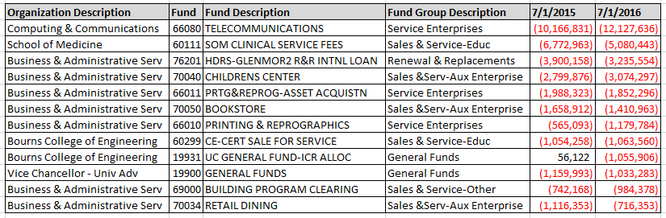

We were able to obtain satisfactory explanations and action plans for the deficits above (some are being tracked as part of a Management Corrective Action (MCA) in R2016-11).

An analysis of surplus balances greater than $1,000,000 at July 1, 2016 (all Business Administrative Services (BAS) related) follows.

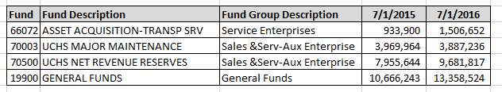

We obtained satisfactory explanations supporting these surpluses.

- Contracts & Grants Deficits

Total C&G deficits have not changed significantly (from $331k to $339k) from April 30, 2016 to April 30, 2017. C&G deficits were reported in detail in our Analytic Review audit (R2016-11).

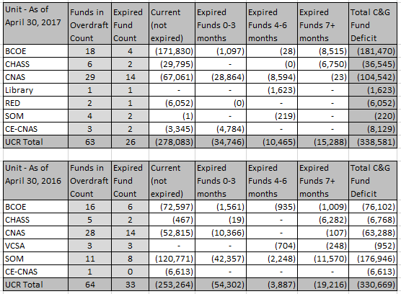

Overdrafts may imply that the University does not have proper controls in place to prevent or detect unallowed expenditures in a timely manner. Overdrafts inhibit the Central Accounting Offices’ ability to bill or close out contracts in a timely manner as required by sponsors which could lead to fines, disallowances, etc. Ultimately, overdrafts need to be moved to other funding sources. If it involves C&G funding sources, then they need to be moved within 120 days and require appropriate approvals and documentation. Agency auditors consider late cost transfers to be high risk transactions that may be considered “red-flags” for additional inquiries and audits. It should be noted that all the deficits above represent < .2% of total C&G appropriations for the FY, except Library which was at 2.4% of total appropriations.

UCR clears out the C&G deficits at year end for the external financial audit and Uniform Guidance (formerly A-133) audit. The entries are then reversed in the beginning of the following FY. It is our understanding that the UC Office of the President requires all C&G overdrafts to be cleared by fiscal year-end. However, the method used by UCR to clear out the deficits is not a good accounting practice.

Management Response – CNAS

CNAS utilizes the CNAS Financial Analysis Reporting System, which allows the unit to systematically monitor deficit balances, the number of cost transfers performed and number of transactions occurring after fund end date. These reports are run quarterly by all units within the college by Dean’s Office financial staff. The reports are then provided to departments to collect comments for each fund such that we have a more thorough understanding of underlying cause. We look for trends, system failures and other areas that may provide opportunity for process improvement. The final reports, with department commentary, are reviewed in a group meeting with the Dean’s Office finance team and the CFAO. The CFAO signs a copy each quarter to certify she has reviewed, taken action on, and understands any deficit balances on the ledger. Each deficit report shows the balance at the end of the most current quarter as well as the balances in the three prior quarters for comparison. This affords the opportunity to immediately examine the persistence of a problem and address it.

Management Response/Corrective Action – BCOE

BCOE is currently in the process of refining processes associated with post award administration for the college. BCOE leadership is implementing new internal controls to address areas that require further oversight/ attention based on a root cause analysis being conducted. The Dean’s Office will be taking a more active role in establishing appropriate accountability measures to ensure that fund overdrafts are avoided and when they occur addressed immediately. BCOE will be requiring that the department/center Financial and Administrative Officers (FAOs) work directly with their Principal Investigators (PIs) to closely monitor their contracts and grants for appropriateness of expenses/overdrafts via the dissemination of monthly PI reports. While this is the current practice, staffing shortages in the departments have, at times, resulted in contract and grants not being closely monitored to avoid overdrafts. Given such, BCOE is currently hiring an extramural funds administrator to provide oversight for all contract and grant activity within the college. This individual will be partnering with the department FAOs and Contract and Grant Analysts to ensure adequate and timely review of expenditures and balances. Additionally, BCOE is also implementing a quarterly contract and grants report to be submitted by the departments/centers to the Dean Office certifying review of all contract and grant activity and ensuring appropriate action on any overdrafts/deficits.

Management Response/Corrective Action – CHASS

The majority of contracts & grants are in our Psychology department. Over the last couple of years, they have had tremendous turnover in their staff positions. To assist Psychology and the entire college, we have re-structured our C&G staff and have created a contract & grant team with a dedicated C&G manager that will have direct oversight over the C&G function within the college. In connection with this restructure and with the increase in contracts & grants as a result of the increase in faculty hiring in Psychology and the rest of CHASS, we have added an additional C&G analyst position specifically for Psychology which was filled in March of 2018. Additionally, we are currently recruiting for an additional C&G Analyst to assist with contracts & grants in the other departments in CHASS and will be part of the C&G team. With these changes in place, we feel confident that these deficits should be reduced significantly.

- Accruals and Year End Closing Process

The year-end closing process is a complicated and highly coordinated effort that not only coordinates efforts across UCR, but is handled in coordination and dependent on other UC campuses and Office of the President (OP). Accounting Services described a process that includes over 400 closing steps. General Ledger systems and the chart of accounts are distinct across the campuses and even at OP, requiring complicated mapping and additional entries for consolidation.

While we do not question the effectiveness of the year-end closing process, we noted some opportunities to improve efficiency.

Some of the items discussed in the observation below describe existing functionalities and features in PeopleSoft Financials/Supply Chain Management (FSCM) that are not presently utilized, that can improve internal controls and enhance efficiency. However, our current version of PeopleSoft (V8.8 upgraded in 2005) is heavily customized and no longer supported. Implementing these features in the present environment may be risky and not cost effective. Many feeder systems (including in-house developed systems) would have to be remediated and we would still forego other features that would be available in the current version release.

BFS and ITS are currently in the process of exploring options to upgrade our financial system. They will evaluate whether they can implement a “vanilla” ERP system and replace the in-house/customized applications, where possible. As such, they believe utilization of enhanced functionalities should be deferred for consideration until a full system replacement decision has been reached and UCPath related remediation has been completed.

Accruals

To comply with Generally Accepted Accounting Principles (GAAP), expenses for goods and services should be recorded in the fiscal year to which they relate, and income for goods and services in the fiscal year earned. In order to meet the fiscal year-end and financial reporting deadlines, accrual and deferral entries are processed based on materiality thresholds set by UCR as follows:

Materiality Thresholds
$10,000 – July 1 to 5
$25,000 – July 6 to 12
$50,000 – July 13 to 19
$75,000 – July 20 to July 31
$100,000 – August 1 to August 30

However, we note that the thresholds above and the process are unusual and may not be considered a common business practice. Many organizations set a single materiality threshold, and usually set a due date within a week of year-end to record these entries. Some universities (comparative in size and nature to UCR) set accruals as follows:

- UC Davis - $10,000 threshold
- University of Texas – Dallas – by day one of close - $2,000 threshold
- The Ohio State University System – within five days of year end (nine days for health system) – threshold not specified

To tier the accrual thresholds over an extended period of time implies that we are creating accruals based on the invoices presented after year end (which can be incomplete) versus a more sound accrual process driven by commitments (contracts and POs) and receipts of goods and services.

UCR does not have an automated accrual process (discussed below), and the process to identify and record accruals is decentralized and manual. At UCR, there were 189 manual ACR (accrual/reversal) journals with 4,031 journal lines at FY ended 2015-16. This includes some items that are not really accruals as noted in Observation III.C above. The accrual postings were made from July 2, 2016 through August 4, 2016. Although we were unable to determine the exact number of individuals submitting accrual entries (because they are centrally posted), we have reason to believe that this is a high number.

Automated Accrual Capability Some organizations use their financial systems to record automated Purchase Orders (PO) Receipt Accrual (PORA) entries thus reducing manual accruals. UCR’s PeopleSoft ERP system has PORA functionality, where it can make a single, centralized, automatic, highly accurate, and timely accrual entry. UCR does not currently use this functionality. Remaining, non-automated accruals, (i.e. non-PO items), which should be fewer, are manually accrued. Accounting Services indicated that there are several factors contributing to our inability to use PORA. For example, UCR uses eBuy, an in-house developed system, to capture many components of the Purchase Order. While some of those data fields are interfaced to the PeopleSoft PO module, not all the required fields are interfaced or captured at the same level in both systems.

Timing of Closing AP One factor that may be contributing to the high number of accruals is the practice of closing the Accounts Payable (AP) subledger on June 30th. Many companies hold open their AP subledger for an extra day or two in order to get invoices received before year end into the system and posted to the prior year.

System Integration Another factor contributing to the high number of manual accrual JEs at year end is the fact that Architects & Engineers (A&E) uses a separate cost accounting system CPMX, which does not interface its POs and contracts with the PeopleSoft AP system. A&E has a high volume of manual accruals entries.

Period 998 Period 998 is a period falling after period 12, and is usually reserved for year-end audit adjustments proposed by the external auditors as part of their financial audit. Such entries are usually few in number and are recorded “topside”, which means that they are not recorded at the unit/department, project, fund level. Instead, they are recorded at the central office department to central office FAUs.

UCR uses period 998 differently. In this period, we noted 342 Journal Entries (JEs) containing 7,524 JE lines that were made between July 12, 2016 and August 6, 2016. Although some of these entries originate from a number of individuals in various departments, they were entered by the Central Accounting Office staff. While we closed period 12 for FY 2015-16 by July 6, 2016, we essentially use period 998 as an extended period 12 instead of adjusting our process to “hard close” period 12 and reserve 998 for “post close” audit entries. Some of the entries in Period 998 are accruals, which as mentioned above, the volume of these entries can be reduced by changing the accrual process. Some of the entries should not be made at all (Observation III.C – C&G Deficits).

Days to Close UCR closed its FY 2015-16 books on August 6, 2016 (36 days after the June 30 year-end). We noted that some comparative universities close their books as follows:

- The Ohio State University system in 19 days (exclusive of Period 998 which is only used for year-end audit adjustments),
- The University of Texas – Dallas in 17 days.

In addition to the items mentioned above, perhaps contributing to the work load during the closing period are some entries that that are immaterial, and perhaps could be recorded in the new fiscal year.

Management Response–Business Financial Services - UCR closes its books and submits the required files to UC Office of the President per their timeline for the consolidated UC financial statements. Audit adjustments made after the June final submission are recorded in the UC Corporate Financial Reporting System using the FJE application.

E. Payroll Cost Transfers

Payroll Cost Transfers (PCT) comprise 5% of total payroll volume (same as prior FY). Some note-worthy observations include:

- Although SOM PCTs decreased compared to the prior FY, the PCT transactions and amounts are still considered high.
- PCTs for Cooperative Extension (CE)-CNAS, UC Institute for Mexico and the United States (UC MEXUS), Athletics and Vice Chancellor University Advancement (VCUA) have significantly increased this year compared to the prior FY.

The four Shared Service Centers should consider these observations with respect to their clients (departments/units) due to the large volume of work involved with C&G-related regulations and associated risks.

Expense transfers, if pertaining to Contracts & Grants are an area of high risk and scrutiny by outside agencies. Exceptions in this area can place the university at risk of disallowed expenditures, penalties and fines and debarment in extreme cases.

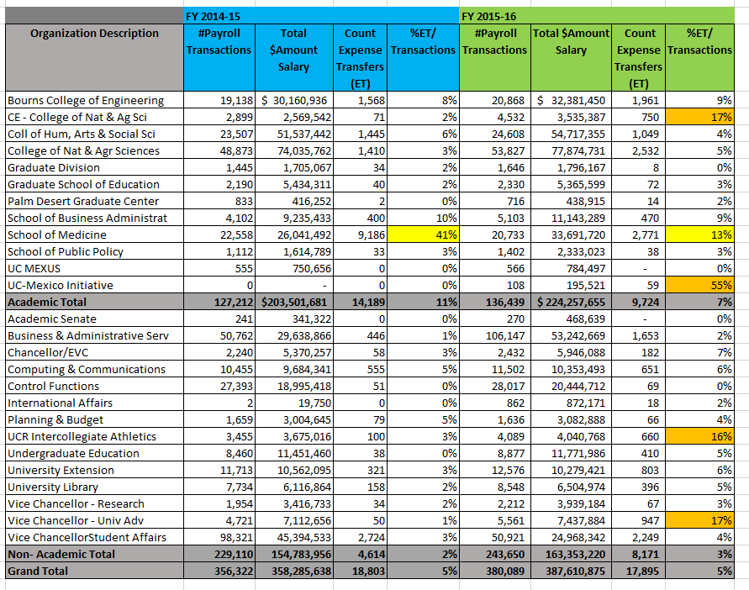

Management Response/Corrective Action – SSCs

The following is a combined response from the 4 SSCs, regarding the increased volume of salary cost transfers on the campus. The summary also reflects the feedback received from our clients.

Historical Factors (FY 15-17)

- Normal operations by departments and PIs (correct errors and as a result of more thorough payroll reviews).
- Changes in fund sources from sponsors (such as UCOP) which are outside the control of departments/organizations and therefore SSCs.
- Awards allocated well after the 120-day rule. Unfortunately, pre-award delays due to negotiations between the unit and the sponsor. Once the awards have been established, the department is then able to allocate expenses.
- Sponsors submitting installment payments more than 9 months in arrears. Rather than allow the fund to go in deficit and incur negative Short Term Investment Pool charges, the expenses are moved to a temporary FAU, and once funds have been appropriated, expenses are moved back to the appropriate fund.
- Recharge rationalization, reorganizations/transfers within and across multiples units, FAU changes for 19900 funding, and late communications regarding funding source changes.

UCPath Conversion Impact

Thorough payroll reviews have increased in difficulty given limited information available to SSC clients since the UCPath launch. There is no reporting, for example, on future dated FAU changes which is a deficiency in the ability to audit and plan. There were a number of errors with payroll for December 2017 through February 2018 for Health Sciences faculty. Examples include, the National Institutes of Health (NIH) cap was not appropriated correctly, some faculty were over/under paid, vacation credits posted to a default FAU, etc. These required cost transfers to correct the error. These also negatively impact grant draw-downs for Extramural Fund Accounting office, as adjustments to draw downs are needed to correct Faculty salary. Additionally, TARS no longer allows departments to split reported time across multiple FAUs.

As a result of these factors, the campus should anticipate an increase in cost transfers until campus systems are fully remediated in the post UCPath environment. After systems and related processes are optimized, we anticipate there will be efficiency gains and as a result, a decrease in the number of cost transfers.

Audit Note: The Management Response/Corrective Actions above were provided in April 2018. We will perform follow-up procedures in the future to review the status of management action.

http://afs.ucdavis.edu/systems/kuali/fiscal-close/accruals-deferrals.html
http://www.utdallas.edu/afr/files/FY15YECoordinationMeeting.pdf
http://controller.osu.edu/acc/acc-doc-genled.shtm
Some of the JE’s tagged as ACR (accrual source code) are not accruals. The source code is used because it creates reversing JE. Reversing JEs can be created with alternative source codes.
For example, Princeton uses PORA to automatically accrue expenses over $2,500. Non-standard accruals (requiring manual entry) are made by 13th day of close (excluding topside accruals like period 998). https://finance.princeton.edu/how-to/financial-management/year-end-close/year-end-accruals/index.xml
Note that even without PORA, there are still queries that can be run to create a central upload JE for accrual, which would pull receipts on PO lines not invoiced. In this environment, such a query may be more difficult as not all of the data resides in the PeopleSoft PO module, and instead resides in eBuy, an in-house developed system.
http://controller.osu.edu/acc/acc-doc-genled.shtm
http://www.utdallas.edu/afr/files/FY15YECoordinationMeeting.pdf

