CONFIDENTIAL

CONTINUING EDUCATION OF THE BAR
AUDIT REPORT #23-731801

Audit & Advisory Services
June 2023

CONTINUING EDUCATION OF THE BAR
AUDIT REPORT #23-731801

Background

Continuing Education of the Bar (CEB) serves the California legal community by providing law practice-oriented tools and resources for legal guidance. It is a standalone unit at UCLA, with a direct reporting relationship to the Dean of UCLA Extension (UNEX).

CEB is located in Oakland, California and employs approximately 110 employees, including legal professionals to write, edit, and produce print and electronic content for sale. The CEB Executive Leadership team consists of eight Directors and Officers that report directly to the Executive Director. Print inventory is warehoused at the Production Distribution Center (PDC) located in Oakland, California.

CEB utilizes Agresso, an internal accounting software, to document and record accounting transactions, such as accounts payable, accounts receivable, fixed assets, revenues and expenses. Reconciliations are performed monthly to reconcile Agresso accounting records to the UCLA Campus (Campus) general ledger. The Automated Inventory Management System (AIMS), Tandem System and the Fusebill subscription billing system are used to process customer orders and returns. Fusebill was implemented by CEB for all digital subscription products, which include OnLAW (CEB’s authoritative secondary sources, in curated practice area libraries), Membership and Programs. Fusebill also facilitates credit card charges for purchases placed on the CEB website.

For fiscal year 2021-22, CEB generated net income of $2.2 million. Assets at year-end totaled approximately $29.6 million. Total assets include cash of approximately $22.8 million, net accounts receivable of $2.9 million, inventory of $2.9 million, and net fixed assets of $413,915. Total deferred income equaled approximately $3.7 million. Refer to financial statements provided by CEB on September 6, 2022, which have been included as an attachment to the audit report.

Purpose and Scope

The purpose of the audit was to review CEB’s selected balance sheet accounts as it relates to reasonableness, completeness, and controls surrounding accuracy of the information. CEB’s reasonable adherence to University financial policies was addressed. UCLA Audit & Advisory Services (A&AS) performed the internal audit as part of its annual audit plan for fiscal year 2022-23.

The scope of the audit covered the following activities:

- Inventory Valuation
- Cash and Cash Equivalents

The audit was conducted in conformance with the International Standards for the Professional Practice of Internal Auditing and included tests and other procedures considered necessary in achieving the purpose. Financial ledgers, vendor invoices, CEB prepared schedules and various other documents were examined.

Summary Opinion

Based on results of the work performed within the scope of the audit, CEB has established effective systems of internal controls and business practices pertaining to inventory valuation and cash and cash equivalents. However, improvement in the following areas are warranted:

Inventory Valuation
- Management should develop a written policy that outlines the specific record retention requirements for all types of documents and data related to capitalized costs. The policy should specify the length of time that records must be retained, the method of retention, and who is responsible for retaining and disposing of records. Additionally, if supporting documentation for a capitalized cost is missing, management should remediate the issue in a timely manner, including conducting further research and/or contacting external sources to obtain missing documentation.

Cash and Cash Equivalents
- Management should ensure that cash balances are reconciled between Agresso and the Campus general ledger timely, accurately, and are aligned with University policies. This could include a review of the documentation for any reconciling items such as outstanding checks, deposits in transit, or bank errors. Outstanding items should be investigated to determine whether items are valid, need to be adjusted, or written off in a timely manner. Lastly, verification of accuracy of data should be examined on a regular basis, to ensure transactions are recorded accurately within the accounting system and that there are no unreconciled differences.

The audit results and recommendations are detailed in the following section of this report.

Audit Test Work and Audit Results
# | OBSERVATION and CRITERIA, where applicable | RECOMMENDATION | MANAGEMENT’S REPONSE
INVENTORY VALUATION
Audit work included the following:

- A physical inventory count was performed to determine that inventory was reasonably stated on the financial statements as of June 30, 2022 and that the items were physically on hand at the end of the fiscal year.
- To complete the physical inventory count, an auditor traveled to Oakland to visit the PDC on July 1, 2022, and met with the PDC Supervisor. The auditor and CEB staff spent the day discussing inventory processing protocols and touring the PDC facility. Inventory items consist primarily of practice books and practice book updates. Thirty inventory items were selected by the auditor for testing. Test counts for each inventory item were performed and agreed to CEB’s inventory reports.
- Total inventory value was recalculated for 17 of the 30 inventory items selected for review with a total dollar value of $172,815. The remaining 13 inventory items were excluded from testing because no prior year issues were noted which warranted decreasing the tested population. Total inventory value was recalculated by multiplying total inventory on hand (which was previously counted by the auditor during the inventory observation) to each product’s unit cost less any inventory write-offs. Total inventory value was reconciled to CEB’s book inventory calculations and to their general ledger as of June 30, 2022.
- Test work was performed to determine that inventory costs are assigned to print inventory in accordance with CEB’s stated valuation method. Discussions about CEB’s inventory valuation process and internal controls related to the process were held to determine that costing procedures were appropriate, and that all product costs were accumulated and allocated to each individual product included in the inventory. Further inquiries were made to evaluate any changes and updates made to the valuation process during the fiscal year. A sample of 17 products was selected for audit testing. Of the sampled 17 inventory items, one selection was a new title comprised of a practice book publication that was newly published during fiscal year 2021-22. The remaining 16 selections consisted of current titles that were reprinted for sale. For purposes of audit testing, a current title is defined as a practice book or a practice book update that was newly published prior to fiscal year 2021-22 and included in total inventory as of June 30, 2022. An inventory cost detail spreadsheet and documentation to support the costs allocated to each sampled item discussed above was provided to A&AS.
- Based on the supporting documentation obtained for the new title selection (comprised of practice book publication), the auditor performed audit procedures to verify that: recorded direct labor and direct materials of costs of $7,231 and $2,865, respectively, are accurate and properly included in total product cost; overhead cost allocations of $26,416 are properly computed and recorded; and, no honorarium payments were noted.
- Based on the supporting documentation obtained for each of the 16 current title selections (comprised of practice books and practice book updates), the auditor performed audit procedures to verify that: reprint unit costs for practice books are accurately calculated and properly reflected in the valuation account calculations; and recorded direct labor and direct material costs of $79,047 and $165,463, respectively, for practice book updates are accurate and properly included in a product’s total cost.
Issues noted are summarized below.

1 | Record Retention  Per Continuing Education of the Bar (CEB) Management, CEB was unable to provide supporting documentation surrounding a capitalized cost of $341,860 related to CEB's Practitioner (Platform) which is an annual web-based subscription product that provides all-in-one practical guidance and legal research solutions. The amortization of the Platform cost began in July 2019, which was before CEB's Director of Finance and Accounting Manager joined the organization. Because of management transition, proper record retention was not followed and as such, supporting documentation does not exist or cannot be located. Audit & Advisory Services noted the cost associated with Platform was fully amortized as of 2021-22 fiscal year end.  ___________________  Criteria:  UCOP Record Retention Schedule, Record Code 0005A2*, Financial and Procurement Records, "These are records that document the financial and procurement activities of the University. These records relate to the bond financing, lending and banking, accounting, procurement, travel management, asset management and tax activities of the University. The records may include but are not limited to documentation of accounts receivable and payable records, deposit records, capital equipment and fixed asset inventories; and other related records. Official Record: Retain records for 5 years after the end of the fiscal year in which the bond matures, or 10 years after the end of the fiscal year following completion of the project - whichever is longer. All Other Copies: Copies are considered non- records, and should be retained only until their usefulness has passed, but never any longer than the official record." | Management should develop a written policy that outlines the specific record retention requirements for all types of documents and data related to capitalized costs. The policy should specify the length of time that records must be retained, the method of retention, and who is responsible for retaining and disposing of records. Management should review current practices for record retention and ensure that they are aligned with University of California Office of the President's (UCOP) Record Retention Schedule. Management should also ensure policy is being followed consistently across the organization, which may include regular training for employees on record retention requirements and monitoring of compliance with UCOP's Record Retention Schedule. Additionally, if supporting documentation for a capitalized cost is missing, management should remediate the issue in a timely manner, including conducting further research and/or contacting external sources to obtain missing documentation. | We have located the backup for the $341,860 asset in our FY 18/19 audit files and delivered this to the audit team. Liya Koo was Controller at this time and put together the support for the amount we capitalized. The capitalization was audited by a prior A&AS Auditor at the end of fiscal year 2019. We will retain the Microsoft Excel copy of the calculation backup in the CEB drive and copies of invoices related to this asset in accordance to the UCLA Record Retention Schedule. Going forward, we will ensure that our audit folder is updated and clearly marked to ensure current and future employees can easily find and refer to capital project worksheets and calculations. We will review the UCLA Record Retention Schedule with new employees to ensure we are in accordance to University guidelines. Also, we will develop a written policy for CEB’s record retention policy related to capitalized costs.
CASH AND CASH EQUIVALENTS
Audit work included the following:

- Test work was performed to determine that cash and cash equivalents existed at June 30, 2022. Cash includes cash on deposit in a depository institution and cash equivalents. Cash equivalents are short-term, highly liquid instruments that are easily convertible to cash.
- Cash transactions are posted to one Campus general ledger cash account that is shared by all Campus departments. Each department is responsible for reconciling their deposits to the Campus general ledger to ensure that cash and cash equivalents have been properly and accurately recorded.
- The use of one general ledger cash account does not allow for cash balances to be reported separately by department on the Campus general ledger; therefore, CEB prepares the reconciliation described below to validate the cash balance recorded on its balance sheet.
- Audit procedures were performed to verify cash and cash equivalents balances at June 30, 2022. Due to the factors mentioned above, audit procedures consisted of reviewing CEB’s cash reconciliation and testing deposit records to determine that cash and cash equivalents were properly and accurately recorded on the Campus general ledger and that CEB reconciles its deposits to the Campus daily bank deposit records.
- CEB prepares a year-end reconciliation consisting of both balance sheet and income statement account balances to reconcile the cash balance per CEB’s accounting records to the Campus general ledger. A recalculation of the cash reconciliation for the fiscal year ended June 30, 2022 was performed to confirm its controls surrounding accuracy. The account balances used in the reconciliation were agreed to each corresponding Campus general ledger account to further validate that the amounts used in the calculation are reasonably accurate and that the ending cash balance is reasonably stated at fiscal year-end.
- Five deposit records for fiscal year 2021-22 were sampled for testing. For each record, the deposit total amount on the bank deposit slip was compared to the amount processed within CASHNet, and recorded on the Campus general ledger. It is CEB's responsibility to verify and reconcile their cash balances on a monthly basis to ensure deposits recorded on the Campus general ledger are correct and properly posted on the general ledger.
- Further, deposits made to Bank of America for fiscal year 2021-22 were verified against monthly bank statements and copies of remittance advices for the months of July 2021, September 2021, October 2021, January 2022, and March 2022.
Issues noted are summarized below.

2 | Unreconciled Balances  Audit & Advisory Services (A&AS) noted an unreconciled difference of $32,050 between Agresso and Campus general ledgers. CEB reconciles financial statement line items from the UCLA General Ledger to CEB's final cash balance via the Working Capital Available (WCA) reconciliation. CEB was unable to locate the source of the variance. Management indicated that reconciliations will be performed and validated at FY23 year-end. Also, adjustments for current year and prior year reconciling items will be made at year-end.  ___________________  Criteria:  UCLA Policy 360 Internal Control Guidelines for Campus Departments, Section 3D, Review and Reconciliation (pg.4): “Departmental accounting records and documents 1) are examined by employees who possess sufficient understanding of the University financial system to verify that recorded transactions actually took place and were made in accordance with prescribed procedures; and 2) are compared with University financial system reports and financial statements to verify their reasonableness, accuracy and completeness.” | Management should ensure that cash balances are reconciled between Agresso and the Campus general ledger timely, accurately, and are aligned with University policies. This could include a review of the documentation for any reconciling items such as outstanding checks, deposits in transit, or bank errors. Outstanding items should be investigated to determine whether items are valid, need to be adjusted, or written off in a timely manner. Lastly, verification of accuracy of data should be examined on a regular basis, to ensure transactions are recorded accurately within the accounting system and there are no unreconciled differences. | The unreconciled balance at the end of FY2021-22 was a result of the reporting of the final day of credit card charges we reported to UCLA on June 30, 2022. Due to the timing of transactions being loaded to the Agresso financial system, the final cash collection report to UCLA of $71,124 included transactions that did not get updated to CEB financials in Agresso until July 1, 2022. This caused a higher AR balance at end of the year, which then resulted in an AR true up adjustment that credited the UCLA expense ledger account 04-611397-ED in error. CEB should have recorded these transactions in Agresso on June 30th as unapplied cash – debit Cash, credit AR – to ensure that the CEB AR ledger was correct.  We have identified the source of the variance and we will adjust for this amount at year end to correct the CEB Reserve account and reconcile our WCA.  Going forward, the following reconciliations will be done on a monthly basis, both to reconcile CEB’s internal financial records with the CEB UCLA ledgers: the WCA reconciliation and the UNEX to CEB income statement reconciliation. At year end we will reconcile the CEB reserve to CEB reconciliation prior to completing our year end entries to make sure everything reconciles as expected.  This year, CEB has improved the cash reconciliation process by hiring a new General Accountant who has developed a daily procedure to ensure that all cash in reconciles to what shows up in the UCLA AR ledger, to BofA and ensures the transaction is properly recorded in Agresso.  At year end, we will enact a new process to isolate from the final day cash deposit any payments that do not show in Agresso, by posting an entry to debit unapplied cash and credit AR. This will correct our AR balance at year end prior to any year end accruals.  Finally, CEB is implementing a new financial system, NetSuite, to replace our legacy order management system, Tandem, and the legacy accounting system, Agresso. The timing issues we see now from those systems will be eliminated as all transactions and accounting will occur in the same system. We feel that this will simplify CEB’s cash reconciliation process considerably. The Go-Live date for NetSuite is November 1, 2023.

CONFIDENTIAL – INTERNAL USE ONLY

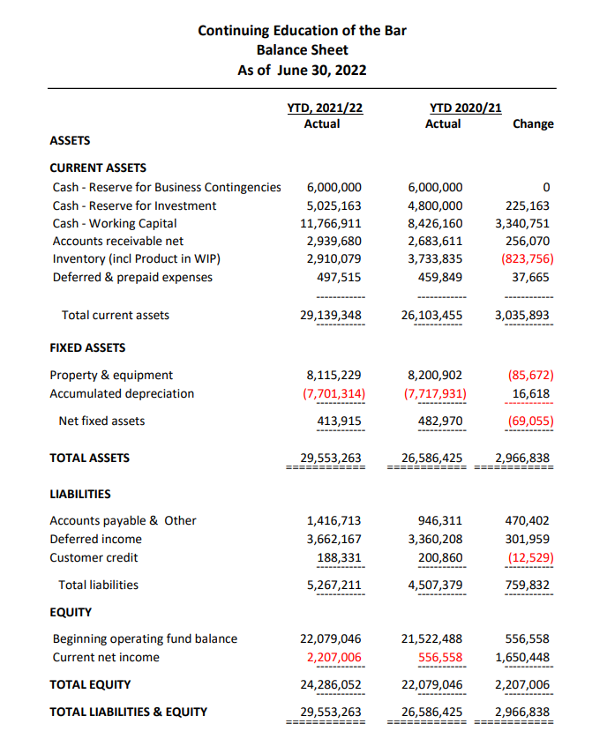
Note: The CEB Balance Sheet as of June 30, 2022 was obtained from Carie Saxton, CEB Accounting Manager on September 6, 2022. A&AS did not review line item financial information included other than Inventory and Cash and Cash Equivalents per audit scope.
CONFIDENTIAL – INTERNAL USE ONLY

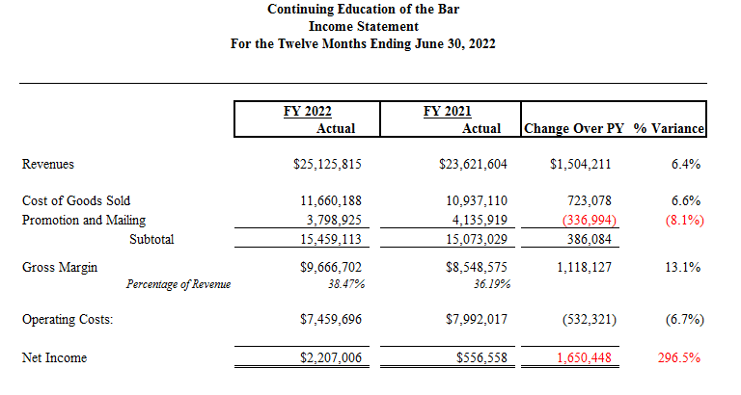

Note: The CEB Income Statement as of June 30, 2022 was obtained from Carie Saxton, CEB Accounting Manager on September 6, 2022. A&AS did not review line item financial information included other than Inventory and Cash and Cash Equivalents per audit scope.

