RIVERSIDE: AUDIT & ADVISORY SERVICES

June 30, 2018

To: Bobbi McCracken,
Associate Vice Chancellor-Business & Financial Services, Accounting
Jadie Lee,
Associate Vice Chancellor-Human Resources

Subject: Overtime and Compensatory Time Audit

Ref: R2017-08

We have completed our Overtime and Compensatory Time Audit in accordance with the University of California, Riverside Internal Audit Plan. Our report is attached for your review. We will perform follow-up procedures in the future to review the status of management action. This follow-up may take the form of a discussion or perhaps a limited review. R2017-08 will remain open until we have evaluated the actions taken.

We appreciate the cooperation and assistance provided by your staff. Should you have any questions regarding the report, please do not hesitate to contact me.

Gregory Moore
Director

cc: Ethics & Compliance Risk and Audit Controls (ECRAC) Committee

UNIVERSITY OF CALIFORNIA AT RIVERSIDE

AUDIT & ADVISORY SERVICES

MEMBER OF ASSOCIATION OF COLLEGE & UNIVERSITY AUDITORS

REPORT R2017-08

OVERTIME AND COMPENSATORY TIME AUDIT

JUNE 2018

Approved by:

_______________________ _______________________
Laura Bishin Toffee Jeturian
Principal Auditor Assistant Director

_______________________
Gregory Moore
Director

UC RIVERSIDE
OVERTIME AND COMPENSATORY TIME AUDIT
REPORT R2017-08
JUNE 2018

- MANAGEMENT SUMMARY

We reviewed the internal controls related to the process of and selected transactions for recording, approving, calculating and paying overtime (OT) and compensatory time (CT) to determine compliance with applicable University of California (UC) policies and procedures, regulatory and contract requirements; and evaluate proper controls and best practices.

Based upon the results of work performed within the scope of the audit, we noted several areas of opportunity to improve efficiency/effectiveness, strengthen internal controls, and/or effect compliance with University policy:

- Individuals with High OT/CT (Observation III.C)
- Negative Confirmations (Observation III.D)
- Shared Service Center (SSC) Responsibilities (Observation III.E)
- Planning, Scheduling and Pre-approval of OT/CT (Observation III.F)
- Sick (SLK) and Vacation (VAC) Conversion to OT/OT Premium (OTP) Payout (Observation III.G)

Minor items not of the magnitude to warrant inclusion in this report were discussed verbally with management.

- INTRODUCTION

A. PURPOSE

University of California, Riverside (UCR) Audit & Advisory Services (A&AS), as part of its Audit Plan, performed an audit of OT and CT. This audit included procedures to study and compare relationships among OT and CT data on a campus-wide basis in order to identify unexpected and the absence of expected fluctuations, trends or activities, and other unusual items. Sample timesheets were examined for compliance with policies, regulations and contracts.

B. BACKGROUND

UCR’s Time & Attendance Reporting System (TARS) is an in-house developed online tool that automates time and attendance reporting and is used to calculate OT and CT accruals for non-exempt staff. TARS interfaced into the Personnel Payroll System (PPS) to update hours worked for non-exempt employees and leave time taken for both non-exempt and exempt employees; this information is ultimately used in generation of paychecks.

Timesheets are submitted on a bi-weekly basis for non-exempt employees. These timesheets are ‘positive pay’, meaning that employees record time worked as a basis for payment. Exempt employees fill out monthly timesheets and only report leave hours (exception reporting). In both cases, the employee’s supervisor approves the employee’s timesheets as required by policy.

C. SCOPE

The review included, but was not limited to the following areas:

- Reviewed UC and UCR policies, regulations and labor contracts related to OT and CT.
- Analyzed OT/CT for four years ended FY 2015-2016 to understand volume/trends and make inquiries as appropriate for any unusual items.
- Interviewed selected departments/units to understand controls over:
  - Planning and scheduling practices
  - Pre-approval of OT/CT
  - Follow-up process for unapproved timesheets
  - Payout of CT at maximum allowed accumulation (240 hours)
- Selected employees with OT/CT to verify:
  - Timesheet approval
  - Pre-approval
  - Business reason for OT/CT
  - Approved timesheets to PPS and recalculated conversion rates
- Performed an analysis of SAS and reviewed selected employees for policy compliance.

Our substantive audit procedures were performed from March 2017 to June 2017. Accordingly, this evaluation of internal controls is based on our knowledge as of that time and should be read with that understanding.

III. OBSERVATIONS, COMMENTS AND MANAGEMENT CORRECTIVE ACTION

- OT/CT by Unit

We performed a four-year analysis from Fiscal Year (FY) 2012-2013 through FY 2015-2016 (only two years ended FY 2015-2016 are shown below) noting that OT/CT represented approximately 1% of total payroll in FY 2014-2015 and FY 2015-2016 ($1,942k versus $1,969k respectively). Overall, payroll increased by 8% from FY 2014-2015 to FY 2015-2016, but OT/CT only increased by $28k (1% increase). The Business and Administrative Services unit had the highest total OT/CT amount at $1.4m in FY 2015-2016 (a $118k or 8% decrease from FY 2014-2015). The Vice Chancellor of Student Affairs (VCSA) unit OT/CT total amount increased by $49k or 44% from FY 2014-2015 to FY 2015-2016.

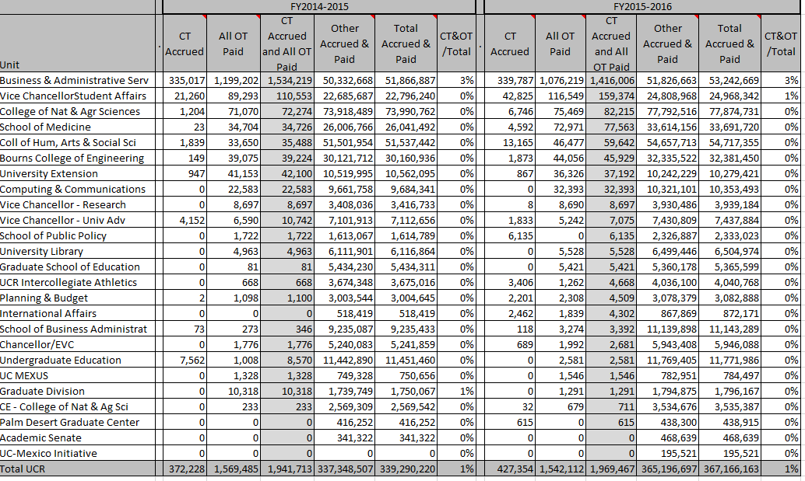

- Units/Departments with the largest amounts of OT/CT (over $10k in FY 2014-2015 or FY 2015-2016)

We looked at four years ended FY 2015-2016 (only two years ended FY 2015-2016 are shown below). Highest OT/CT amounts in FY 2015-2016 were as follows:

- Police $713k (similar to FY 2014-2015)
- Plant Services $148k (decreased by 22% from FY 2014-2015)
- Housing Services $125k (increased by 27% from FY 2014-2015). However, Dining Services OT/CT amounted to $73k and decreased by 52% from FY 2014-2015.

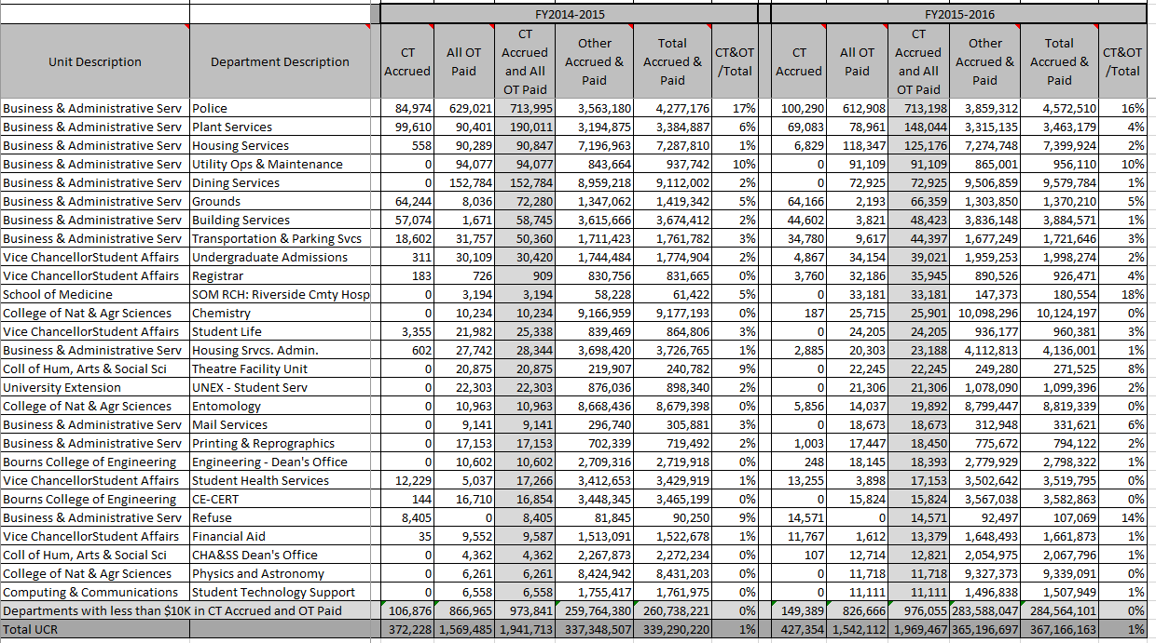

- Individuals with High OT/CT

We found 84 individuals with at least $10k and over 15% of their total pay in OT/CT in FY 2015-2016. Individuals with at least $10k and 25% of their total pay in OT/CT in FY 2015-2016 (count 15) are listed below.

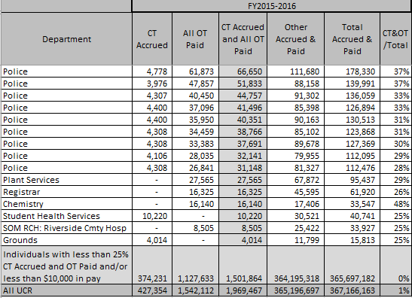

Nine individuals were with the Police department, an industry with typically high OT due to the fact that these individuals are scheduled on long shifts. The Police department’s contract allows for significant OT due to the number of pay types that are OT eligible. Also, service demands have increased due to criminal activity around the campus, which may account for increased OT as well.

We examined the timesheets of individuals from Registrar, Chemistry, Student Health Services, and School of Medicine (SOM): Riverside Community Hospital departments and made inquiries with the respective departments to understand the reasons for the OT/CT. Police, Grounds and Plant Services were not examined as high OT/CT is expected because of the nature of their jobs. We noted exceptions in the following areas:

- Registrar and Student Health Services – The Registrar’s office indicated that many individuals were required to work overtime for the Banner implementation. Vice Chancellor Student Affairs was unable to provide information to support the reason for the excessive OT/CT for the individual in Student Health Services. This individual exceeded the CT maximum allowed accumulation of 240 hours and was paid out 333 hours of Compensatory Time Paid (CMP). We were unable to determine the review process used to ensure that CT is paid out at the maximum allowed accumulation in accordance with UCR policy.

- Chemistry – One individual charged 12 per hours per day, for seven days, for three consecutive weeks. For the timesheet period ended October 10, 2015 through January 2, 2016 (which includes the three consecutive weeks noted above), five of the six timesheets did not have supervisor approval. One bi-weekly period during that time was paid without a TARS timesheet on a supervisor approved email; the employee was paid based on working 12 hours per day for 14 consecutive days. For the bi-weekly period ended January 2, 2016, the employee was scheduled to work seven days and because two days off were taken, the employee recorded 10 hours of vacation on each of those days. That coupled with four paid holidays resulted in the employee working 44.5 hours during an 80-hour period and earning 26 hours of overtime and 4.5 hours of overtime premium (paid at time and a half). We were unable to obtain information from HARVEST (the SSC handling this employee’s payroll) to support the OT. However, we noted evidence of quarterly review of OT at the College of Natural and Agricultural Sciences (CNAS) Dean’s Office where this was questioned and explanations provided were accepted.

- SOM – We noted that one of the three timesheets with OT did not have a supervisor approval in TARS. Also, it did not appear that there was a unit level process to review for instances of excessive OT/CT at the time this occurred. However, the SOM Chief Financial and Administrative Officer (CFAO) indicated that this level of monitoring will be occurring going forward in the SOM even after they migrate to R’SSC (the SSC that will process SOM payroll going forward).

Analysis of prior years’ OT/CT:
- FY 2014-2015 OT/CT approximated FY 2015-2016 OT/CT.
- FY 2013-2014 OT/CT approximated FY 2015-2016, except that we noted one employee in Architects & Engineers that earned 27% of their salary as OT and/or CT. Also, there were two additional Plant Services employees and one Theater employee with significant OT and/or CT.
- FY 2012-2013 OT/CT was similar to FY 2015-2016, but also included a Theatre employee, and some Plant Services and Housing Services employees with significant OT and/or CT.

D. Negative Confirmations

Business and Financial Services management, in a Leave Accounting Audit Report (R2012-21) issued on December 19, 2013, indicated that in order to get 100% compliance with timesheet approvals, they implemented a ‘negative confirmation’ process. If a supervisor does not approve an employee timesheet within 2 weeks of the close of a payroll cycle, then a negative confirmation is recorded and the employee is paid the time as stated in the timesheet. While supervisors can subsequently approve a timesheet, the negative confirmation will not be removed, and there is no reporting mechanism to determine ultimately how many paid timesheets were positively approved.

University Policy IA-101, states: “Individual attendance and job time records shall be approved by the employee's supervisor …” and “…payroll control standards are presented in terms of the most desirable operating conditions. There may be situations … when existing conditions may provide adequate control within the intent of the standards. In such situations, variance from these control standards must have the written approval of the Chancellor…”

Business and Financial Services management believes that the negative confirmation approval process is within policy, and that an exception from the Chancellor is not required. Additionally, Business & Financial Services indicated that “the UCR campus has successfully utilized the negative confirmation process for Federal Cost Transfers (FCTs) for over 13 years. The utilization of negative confirmations for TARS was an informed decision based on workgroup discussions involving Accounting/Payroll, Human Resources, Academic Personnel, Computing, and the Interim Vice Chancellor of BAS.”
We do not believe that this is a sound interpretation of University policy IA-101, nor is it considered a best practice.
We noted that SSC and departments spend significant time following-up with supervisors to confirm zero-hour timesheets and other outliers that impact payroll and to obtain approvals before the timesheet moves into a permanent negative confirmation state. However, ultimately, if there is no subsequent supervisor approval, the campus’ position is that this lack of supervisor approval constitutes approval.

- Negative Confirmation Statistics/Trends - We noted that the number of instances where TARS timesheets are not approved by the supervisor in a timely manner (generating negative confirmation) appears to be increasing (11% for one bi-weekly (BW) and monthly pay cycle in May 2016 versus 3% for one bi-weekly and monthly pay cycle in June 2015). See figures for the bi-weekly and monthly May 2016 pay cycle below.

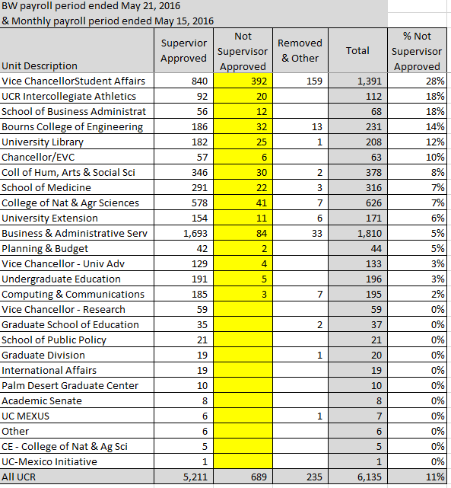
It appears that some of the increases are due to changes in some departments whereby they increasingly do not remove zero-hour timesheets. Once we adjust for such cases (i.e. remove zero bi-weekly timesheets), there are still 8% un-approved timesheets (versus the prior year, which was at 3%). In the case of VCSA, management indicated that they have a number of off-site student workers where their authorizing supervisors are not UCR employees (affiliates). TARS does not have the ability to add affiliates, so these departments obtain ‘wet’ signatures on paper timesheets. Those should be uploaded to TARS for better audit trail. We were unable to determine the number timesheets impacted by this process due to system limitations.

- Timesheets with OT/CT not approved by supervisor in a timely manner (i.e. generating negative confirmations)- In order to obtain a better idea of the number of timesheets with OT/OTP that have no supervisor approval, A&AS selected some timesheets that have the negative confirmation status with OT/OTP pay, and reviewed to determine if a subsequent and timely approval could be located (and ideally loaded into TARS). For the bi-weekly payroll period ended May 21, 2016 and monthly payroll period ended May 15, 2016, we noted 22 individuals with OT/CT without supervisor approval. For these, we requested the respective units/departments to try to locate offline approvals that may have not made their way into the TARS system of record. Following were the results:
    - BAS – 13 timesheets – The department was unable to provide any offline approval.
    - Bourns College of Engineering (BCoE) – 4 timesheets
    - The Center for Environmental Research and Technology (CE-CERT) department provided offline approval for two timesheets and one approval could not be located. We noted that the manual signature approvals were not dated so we were unable to determine if they were signed in a timely manner or in response to the audit. When asked why the department was not requiring timely online approval, or loading these back into TARS, the department indicated that it is unusual to get wet signatures for timesheets, and that it is a challenge to meet the TARS deadlines as CE-CERT’s main funding comes from sponsored awards and they can work on multiple projects. They then would need Principal Investigator (PI) approval, which can be delayed if the distribution does not coincide with the funding source. What is paid in PPS does not always match what is in TARS, but they keep the PI approval for what was paid.
    - For another department, the offline approval was generated in response to the audit (1 year late).
    - CNAS – 2 timesheets - The department obtained supervisor approval (11 months after the fact) and uploaded the documents to TARS.
    - VCSA – 2 timesheets - The department was unable to provide any offline approval.
    - Chancellor/Executive Vice Chancellor – 1 timesheet – We noted that while there was no ‘final’ supervisor approval of the timesheet, there was evidence of supervisor review and a request to amend the timesheet and it appears that the timesheet was amended as instructed.

- Timesheets on Contract and Grant (C&G) funds, not approved by the supervisor - Although not originally part of the scope of this audit, the data we were examining lends itself to the question of how much Federal C&G dollars where charged on timesheets without supervisor approval. For one bi-weekly and monthly payroll in May 2016, we noted 15 timesheets with approximately $7,000 in C&G charges (up from June 2015, which was 10 timesheets with approximately $5,000 in C&G charges). Most were in CNAS and BCOE. This is projected at approximately $180,000 annually in potential C&G charges on timesheets without supervisor approval. These could be considered as questioned costs by external agency auditors. We also noted that unapproved time for Sales & Service charges that ended up on C&Gs could be questioned costs; however, it would be difficult to quantify this. Accounting management agrees positive approval of timesheets is best practice, however, the negative confirmation process, monthly PI reporting and annual payroll certifications minimize the risk to C&G funds. However, CNAS management has concerns about supervisor approval of timesheets on C&G funds and is interested in enhanced and standard audit reports that can identify patterns and risks, and that can be used across all the SSCs to reach a higher standard.
Management Corrective Action – Business and Financial Services - With the implementation of UCPath, expectation of employee and supervisor approval of timesheets was reinforced via the campus in-person and on-line training; the training also outlines expectations of the Shared Services Centers.

E. SSC Responsibilities

Reporting/Monitoring/Follow-up – The responsibilities of the four UCR SSCs are not clear. It is unclear if the departments/units responsible for monitoring/follow-up for unapproved time, excessive OT/CT, compliance with CT maximum allowed accumulation, review of TARS/PPS reconciliation reports, etc. or if there is some shared responsibility with the SSCs.

Monitoring Excessive OT/CT and CT Bank –
- CNAS has a quarterly process whereby the CFAO reviews all OT/CT by department and additional review is made on high OT/CT departments. However, it is not a standard report and like many units, it is something that is downloaded and manipulated. We recommend that with the UCPath implementation, (UC’s program to implement a single payroll, benefits, human resources and academic personnel solution for all UC’s) such reports will be made available and that appropriate query/reporting capabilities will be offered so Units/Departments and UCR SSCs are able to get the information they need to do their reviews in a more efficient manner.
- College of Humanities, Arts & Social Sciences (CHASS) – There was a Management Corrective Action (MCA) in a past Analytic Review Audit R2016-11 regarding the OT/CT review process and high OT/CT in the Theatre department. CHASS and the department now have a review process in place to make sure CT at maximum allowed accumulation is paid out. It is unclear if that responsibility will continue to be assigned to CHASS or if the SSCs will provide that monitoring/oversight.
- BAS - Periodically, BAS prepares reports to understand the amount of OT being worked across its organization. The purpose of the reports is not so much to monitor activity or approval of activity at a granular level, but to look at trends and expenditures. They have had discussions with their Leadership Team about managing OT and minimizing it to the greatest extent possible. However, there will always be areas that need to utilize OT to get the job done, especially at peak times (e.g., Police, Facilities). For its customers, the reporting on OT/CT pay is the responsibility of the customer and is tied to financial planning and analysis. This way, the units can be proactive before expenditures are out of control.

Monitoring Unapproved Timesheets – We understand that the UCPath team is still in the process of reviewing how/if negative confirmations will change with the UCPath implementation, but the biggest change will likely involve ensuring any edits/changes made during the late approval period are processed in UCPath. As such, our SSCs will need to develop best practices and monitoring/implementation policies on negative confirmations. The assumption is that that they will do this in concert with the other three SSCs. The UCPath/Future Operating Model (FOM) team is coming up with a way to track these, but once they go into negative confirmation, there is no process that allows it to be “approved by the supervisor” and cleared from the queue. This may need to be discussed further by management. Additionally, the reports out of TARS are not user friendly. These reports need to be enhanced if the SSC’s are to obtain positive supervisor approval of timesheets.

Monitoring CT Bank Balances at Maximum Allowed Accumulation – In order to review that CT payouts were made in accordance with policy (at 240 hours or 180 for Skilled Crafts represented employees), we requested to review the April 2017 ‘Leave Liability Report (PPP6401)’, however we were unable to obtain such report. The departments receive a departmental version, PPP6401–D every month through iReport. The Payroll Office is not required to review or audit this report as it is a department responsibility. In a past Analytic Review audit R2016-11, we noted that some individuals in Theatre were not being paid out at the CT maximum allowed accumulation. CHASS and the Theatre department implemented a process whereby they now monitor OT/CT and payout CT at the maximum allowed accumulation. R’SSC audits CT utilization for all clients to ensure that the accrual does not exceed 240 hours or 180 hours for Skilled Craft employees. In the rare instance when the accruals exceed the limits, they notify the department and pay out the excess. This is a manual audit because there are no automated stops in the system. It was indicated that this will be remedied as we go to UCPath as TARS will automatically pay out the OT when an employee reaches the maximum allowed accumulation per their bargaining unit contract.

TARS/PPS Comparison Report – This report reconciles TARS hours to PPS by the Distribution of Service (DOS) code. However, the reports only appear to go back to June 2016. We ran this report for the bi-weekly pay period ended June 18, 2016 for three units and selected 13 individuals with OT/CT mismatches to review. We noted no exceptions. However, the differences reported were false positives. It is not clear if this is going to be a department/unit, or SSC responsibility to review these reports going forward. This report is 24 hours old when payroll is being processed as it needs an overnight update. If changes are made to the roster, or a retroactive adjustment (LX/RX) is processed during the payroll process, it will not show on this report. This report is a comparison of TARS to the PPS Roster and is only valuable when the data exists in both places. Excluded from the report is the processing of manual timesheets, LX/RX transactions, multiple appointments, and additional pay. As a result, the comparison report is also incomplete.

Management Corrective Actions:

Business and Financial Services - With the implementation of UCPath in December 2017, extensive remediation of TARS was required to meet the campuses basic business needs. As TARS reports tools are developed to address department and SSC needs, these observations will be considered.

Human Resources –
- Monitoring Excessive OT/CT & CT Bank - As part of the Future Operating Model (FOM) design, an HR Business Partner (HRBP) role was created. It seems that, while the SSCs would be responsible for reporting, the responsibility for monitoring, follow-up and counseling regarding alternate courses of action more appropriately resides with the HRBP function.
- Monitoring CT Bank Balances at Maximum Allowed Accumulation - A UCPath Cognos Report (R-366: Employee's total hours (sick, vacation, hours worked) is now available and can be used to monitor CT accruals, usage and balance.

F. Planning, Scheduling and Pre-approval of OT/CT

  - Planning and Scheduling practices vary by department. For example, the Police department uses the Kronos system to create formal schedules. In some cases, in this and other departments, OT/CT is required by a project/program and may or may not be anticipated/scheduled in advance.

  - Pre-approval of OT/CT - There does not appear to be a formal tracking process at UCR for OT/CT pre-approval, although it is the department responsibility to pre-approve OT/CT.
    - BAS stated that the department heads/supervisors are responsible for ensuring that OT is authorized before it is worked. However, they were not aware of any requirement/policy for pre-approval to be documented and approval of the time report, after-the-fact, is the only evidence that the hours were authorized by the supervisor.
    - Conversely, we noted one department in BCOE has a formal pre-approval document with approvals. We noted, in one case examined, that the document was approved and loaded to TARS.
Management Response – Human Resources - UC Policy & UCR Local Procedures do not dictate a specific pre-approval process for the use of OT/CT. Departments are tasked with communicating their specific pre-approval process to their staff because business needs vary from one department to another depending on the nature of the work being performed.

G. SLK/VAC Conversion to OT/OTP Payout

We noted one instance where a CNAS employee, over many months, was converting SLK/VAC to OT and OTP (1.5 times OT). A Departmental Time & Attendance Administrator (DTAA) questioned one of the many timesheets, but the employee indicated that the Supervisor requested that time be entered this way and there was no follow-up. As a result, it appears that the individual was collecting OT and OTP (1.5 times OT) for hours not worked.

UC Policy PPSM-30 states: “For compensation purposes, overtime is time worked that exceeds 40 hours on pay status in a workweek [subject to some exceptions]. Over-schedule is time worked that exceeds an employee’s regular daily schedule on pay status.”

Sick or vacation hours plus hours worked in a day should not exceed scheduled hours in a day.

We reviewed one month across the whole campus and note that this was an isolated case.

This item was addressed in R2017-05 CNAS Dean’s Office Audit Observation III.A.2 (issued February 27, 2018).

H. Staff Administrative Stipends

We reviewed SAS payments from FY 2013-2014 through FY 2015-2016. The top 10 individuals with SAS payments in FY 2015-2016 are listed below. Total SAS payments decreased significantly from FY 2014-2015 to FY 2015-2016 (31%). It is our understanding that these individuals were backfilling open positions or performing additional work for specific projects. UCR policy states that SAS payments cannot exceed 25% of total salary. We did not find any instances where the SAS payments exceeded this limit.

PPSM-30 Compensation policy in effect since April 10, 2015 states:

“The payment of administrative stipends is intended to be temporary and generally should not exceed twelve months; however, if necessary, one extension of up to an additional twelve months may be approved in accordance with Section IV.C.1 of this policy. An extension of an administrative stipend beyond twenty-four months is an exception to this policy.”

Policy prior to that date was silent on the amount of time that Staff Administrative Stipends were allowed.
We noted several instances where individuals who were working on UCPath were collecting SAS payments beyond twenty-four months. However, since the policy limits were not in effect until April 2015, they did not exceed any limit. Nevertheless, management indicated that that there is exceptional approval for these individuals. The R’SSC provides routine reporting to clients on stipend amounts, duration, and end dates. It is our understanding that all the SSCs are planning to operate similarly so these reports should be available for all departments.
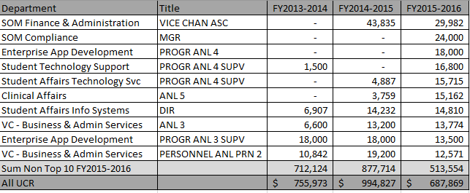

Management Response– Human Resources -
- Individuals with stipends greater than two years were working on the UCPath project. In 2015, University of California Office of the President granted a blanket exception to the administrative stipend duration limit for individuals working on the UCPath project.
- A UCPath Cognos Report (R-362: Administrative Stipends) is now available to central offices and SSCs. It can be used to monitor both the amount (to ensure it does not exceed 25% of the employee’s base salary) and the duration (to monitor 12 months, 24 months & beyond in exceptional circumstances). The SSCs would be responsible for tracking and reporting stipend duration to their clients, but the responsibility for monitoring, follow-up, advising regarding alternate courses of action, and coordinating any necessary approvals lies with the HRBP role.
- HR began providing the Chancellor and campus leadership with a quarterly compensation report which includes any stipends that are out of compliance with policy. Monitoring occurs in HR.

